YUVA INTERNSHIP PROJECT
DATA CLEANING AND ANALYSIS USING R

Submitted by : GUNAL.K

Internship : Yuva internship

Software used : R and RStudio

Project type : Data cleaning and analysis

INTRODUCTION

This project focuses on data cleaning and basic data analysis using R programing. The dataset was analysed using RStudio to understand the data and obtained useful statistical results.
In this project, R programing and RStudio were used to clean and analyse the given dataset. basic statistical function were used to understand the data and obtain useful result
The project also help in understanding the structure of the dataset, the number of records and variables, and important values such as average age and average fare.

Objectives

The main objective of this project are :
      - To understand the given dataset and its structure.
      - To clean and organize the data for analysis.
      - To use R programing for basic data analysis.
      - To calculate the average age and average fare.
      - To identify the number of records and variables in the dataset.
      - To understand and interpret the result obtained from the analysis
Tools used
- R programing
Used for data cleaning, processing, and analysis.
- RStudio
Used to write, run, and manage the R code
- Dataset
The given dataset was used for performing the analysis

Dataset Description

The dataset contains 891 records and 12 variables.

It was examined using RStudio to understand its structure and perform basic analysis. The dataset was used to calculate values such as the average age and average fare.

Dataset Details:
- Number of records: 891
- Number of variables: 12
- Average age: 29.36
- Average fare: 32.20

Methodology

The project was completed using the following steps:

- The dataset was lode into RStudio.
- The dataset was examined to understand its structure.
- The data was cleaned and prepared for analysis.
- Basic statistical calculation were performed using R.
- The number of records and variables was identified.
- The results were obtained and interpreted.

R code

The following R code was used to perform the data cleaning and basic analysis of the dataset.

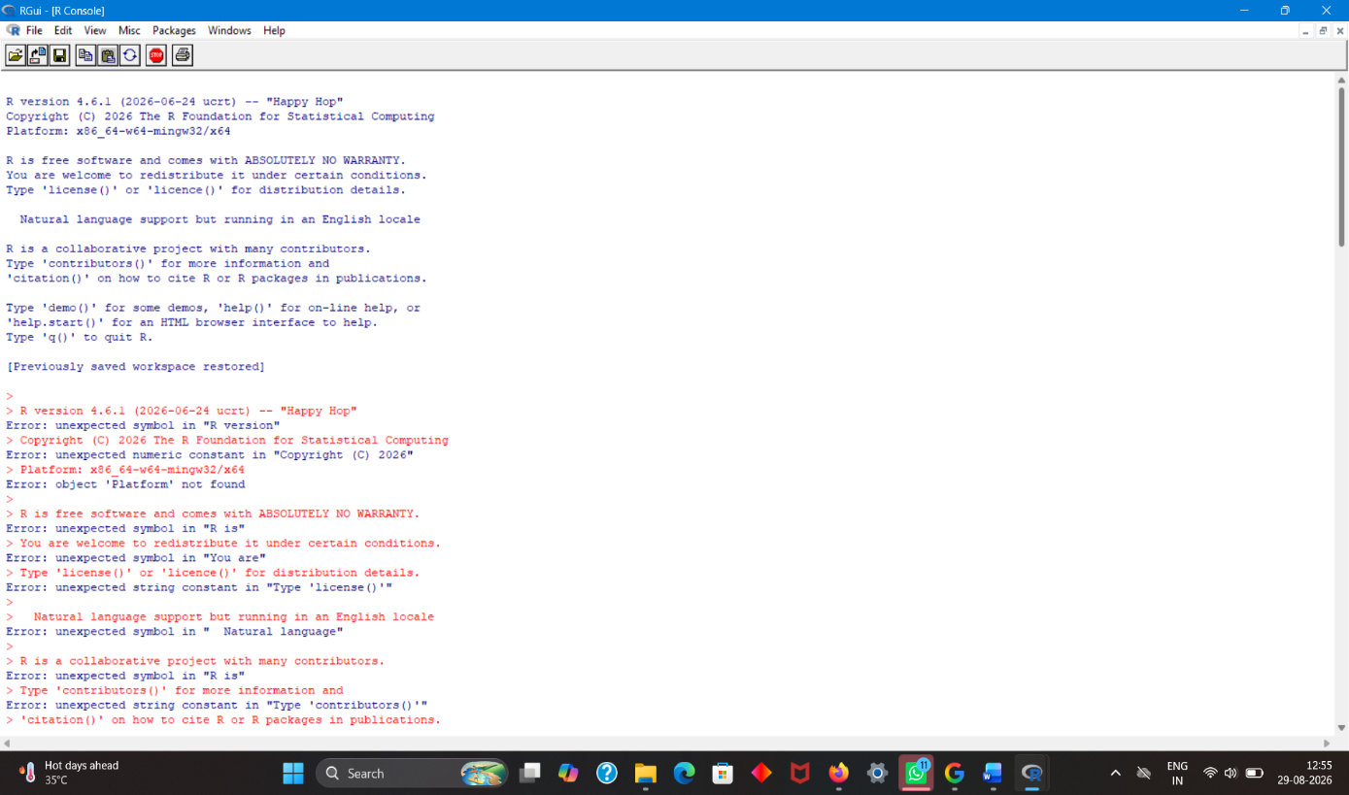
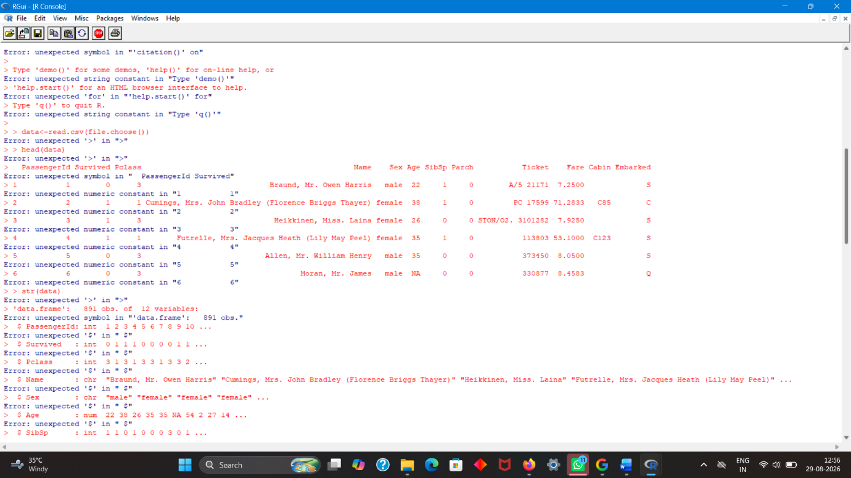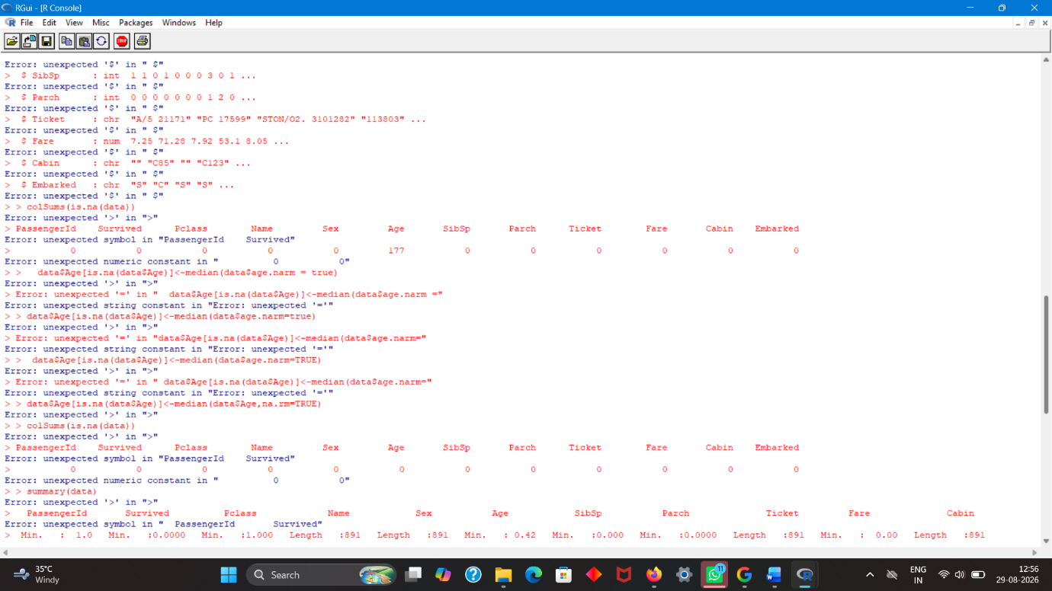

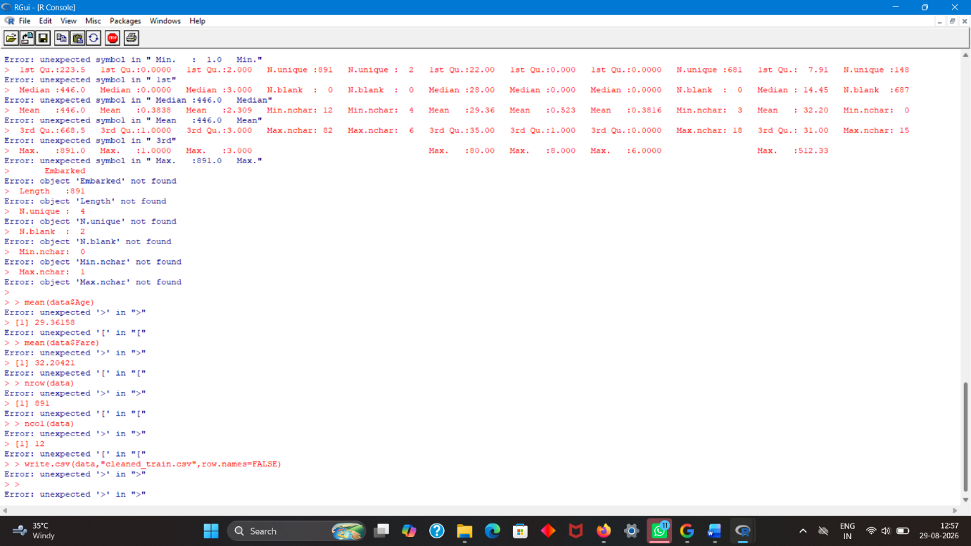
Output and result

The R programing was executed successfully and the following result were obtained:

- Average Age: 29.36
- Average Fare: 32.20
- Number of records: 891
- Number of variable: 12

The result shows the basic statical information and structure of the dataset

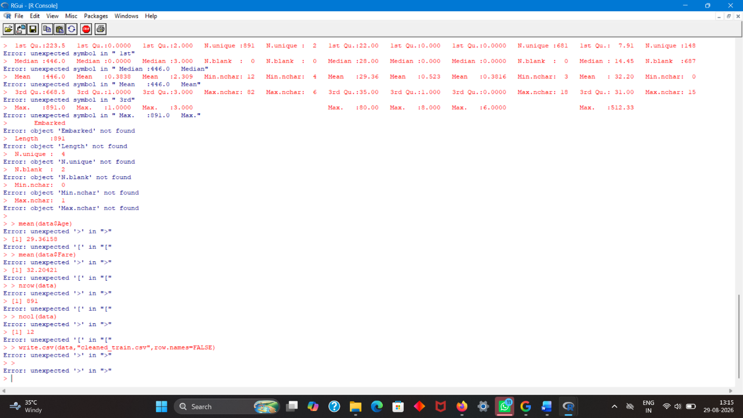

Conclusion
This project helped in understanding data cleaning and basic data analysis using R and RStudio. The dataset was successfully analysed, and important statistical results were obtained. The project also improved understanding of how R can be used to work with real – world data.

1. Dataset Understanding
The dataset used in this project contains 891 observations and 12 variables. Before performing calculations, the dataset was examined to understand the number of rows, the number of columns, and the type of information stored in each variable. Understanding the structure of the dataset is an important first step because it helps identify missing, incorrect, or inconsistent values before analysis.
2. Data Cleaning Process
Data cleaning was treated as an important preparation stage before analysis. The dataset was loaded into RStudio and its structure was checked. The records and variables were inspected, and the data was prepared so that numerical calculations could be performed correctly. The cleaning stage helps improve the reliability of the analysis by making sure that the data being analysed is in a usable form.
The main cleaning and preparation activities included loading the dataset, checking its structure, examining the available observations and variables, and preparing the data for statistical functions. These steps provide a simple and reproducible workflow for working with a real-world dataset in R.
3. Exploratory Data Analysis
After preparation, basic exploratory analysis was performed. The purpose of exploratory analysis was to obtain an initial understanding of the dataset through simple numerical summaries. The number of records and variables was identified, followed by calculations of average age and average fare. These measures provide a quick overview of important numerical fields in the dataset.
4. Statistical Analysis
R was used to calculate the mean values of the Age and Fare variables. The mean is obtained by adding the available numerical values and dividing the total by the number of observations used in the calculation. The calculated mean age was approximately 29.36 years, while the calculated mean fare was approximately 32.20.
These values are descriptive results. They summarize the dataset as a whole and do not by themselves explain relationships between variables. More advanced analysis could be performed in future work if required.
5. Results and Interpretation
The analysis produced four main results: 891 records, 12 variables, an average age of 29.36, and an average fare of 32.20. The number of records represents the observations available in the dataset, while the number of variables represents the columns containing different pieces of information. The average age gives an overall measure of the Age field, and the average fare gives an overall measure of the Fare field.
The results demonstrate that R can be used to quickly inspect a dataset and calculate useful summary statistics. They also show the importance of first understanding the structure of data before drawing conclusions from it.
6. Reproducibility of the Analysis
One advantage of using R and RStudio is that the analysis can be reproduced by running the same commands on the same dataset. Instead of calculating the values manually, R performs the calculations consistently and reduces the possibility of arithmetic errors. The workflow can also be extended later by adding additional statistical functions or visualizations.
7. Learning Outcomes
Through this project, the following practical skills were developed: loading a dataset into RStudio, understanding rows and columns, inspecting dataset structure, preparing data for analysis, using basic statistical functions, interpreting numerical results, and documenting an analysis workflow. The project also provided practical exposure to working with data rather than only studying programming concepts theoretically.
8. Limitations
This project mainly focused on data cleaning, dataset structure, and basic descriptive analysis. Only selected summary values were calculated. The analysis does not include advanced statistical modelling, hypothesis testing, correlation analysis, or predictive modelling. Therefore, the findings should be understood as an introductory analysis of the dataset.
9. Future Scope
The project can be extended by creating charts and graphs to communicate the findings visually. Additional analysis could include comparing variables, studying distributions, identifying patterns, and applying more advanced statistical techniques. R packages such as ggplot2 could also be used to create clearer visualizations and improve insight communication.
10. Overall Project Summary
The project successfully demonstrated a basic end-to-end data analysis workflow using R and RStudio. The dataset was loaded, examined, prepared, and analysed using basic statistical functions. The final analysis identified 891 records and 12 variables and calculated an average age of 29.36 and an average fare of 32.20. The work provided practical experience in handling data, using programming tools for analysis, and communicating results in a structured report.
11. Tools and Working Environment
Programming language: R. Development environment: RStudio. Dataset: the dataset used for this internship project. The analysis was performed using R commands for dataset inspection and basic statistical calculations.

